

**MKTG 758**

**QUANTITATIVE RESEARCH**

**FINAL REPORT**

**Dipanshu Kalra - 301379473**

**Question: How do consumers relate to celebrity models?**

**Introduction**

In the modern world where celebrities are admired and idolized, their influence now extends beyond their primary domains to shaping and affecting our daily lives. With platforms like Instagram, TikTok, Facebook, and others, millions of people regularly check in to keep up with the latest trends and hot topics, often driven by celebrity presence. Celebrities like Kylie Jenner, Cristiano Ronaldo, and Lionel Messi have millions of followers who follow their every move.

Moreover, these social media platforms utilize targeted advertising based on users' interests and searches, effectively influencing buyers' decisions. These online marketing techniques can be used to influence buyers’ decisions especially when the target audience can relate specifically to the subject of the adverts.

**Literature Review**

With the increase in social media usage, it is now easier to keep up with the latest hot celebrities and trends than ever before. According to Nabil et al. (2022), “celebrity endorsement is a persuasion strategy in which customers identify with the person featured in an advertisement. Celebrities promote services and products in ways that serve to increase brand awareness and credibility.” This means that when companies utilize celebrities to advertise their products, they aim to sway consumers into buying their products since they are being advertised by someone they know and trust. For example, seeing Lebron James endorsing Nike will give fans the impression that Nike is a great brand to use when playing basketball and other sports since Lebron is known for being a great player. Therefore, many people may purchase the Nike brand to wear to the gym, for jogging, or to play sports. However, while it is tempting to assume a positive link between celebrity models and consumer purchasing behavior that benefits the brands using this marketing medium, Min et al. (2019) suggests a more nuanced and complex relationship may exist.

**Methodology**

**Research Design:**

This study adopts a quantitative research design, which focuses on collecting numerical data and analyzing relationships between variables in a structured manner. By utilizing this approach, we provide precise and measurable insights into the research questions under investigation. Quantitative methods allow for the systematic examination of patterns, correlations, and trends within the data, offering a robust foundation for drawing conclusions and making informed decisions.

**Sampling Method:**

To ensure the representation of diverse perspectives and demographics, random sampling was employed as the primary sampling method. Random sampling involved selecting participants from the target population in a random and unbiased manner, thereby minimizing the risk of selection bias and ensuring the generalizability of the findings. This approach enables us to capture a broad range of viewpoints and experiences, enhancing the validity and reliability of the study outcomes.

**Sample Size: 159**

The selection of the sample size was guided by age quotas, which ensured proportional representation across different age groups within the population of interest. Age quotas were established to reflect the demographic distribution of the target population accurately, allowing for a balanced and representative sample. By adhering to age quotas, we captured the perspectives and behaviors of individuals across various life stages, thereby enhancing the comprehensiveness and inclusivity of our research findings.

**Objectives:**

**Generic Objectives:**

**This research aims to investigate the level of influence that celebrity models have on customer purchase decisions for sportswear.**

**Specific Objectives:**

**To examine the role of demographic factors on the effectiveness of celebrity endorsements in influencing consumer purchase decisions.**

* Almost half of the Respondents (44%) are willing to pay extra for sportswear endorsed by a celebrity.

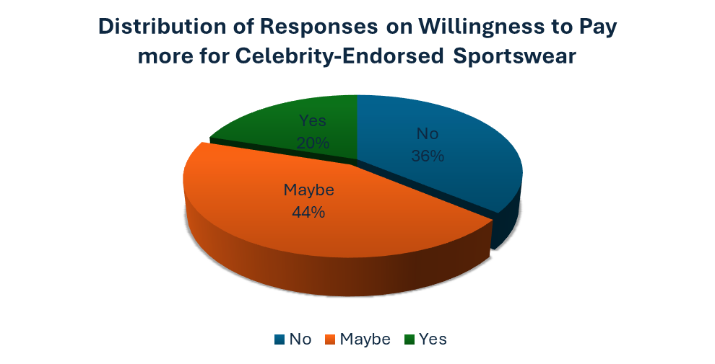

n = 159

**Analysis:**

The finding that 44% of respondents are prepared to pay more for sportswear that is supported by a celebrity shows the impact that celebrity endorsements have on consumers' opinions of the value of a product. This implies that celebrity endorsements help customers rationalize a higher price for a product by increasing the perception of its quality or attractiveness.

* When it came to purchasing a sportswear product endorsed by their favorite celebrity, more than half of the respondents (51%) showed a likelihood to buy the product.

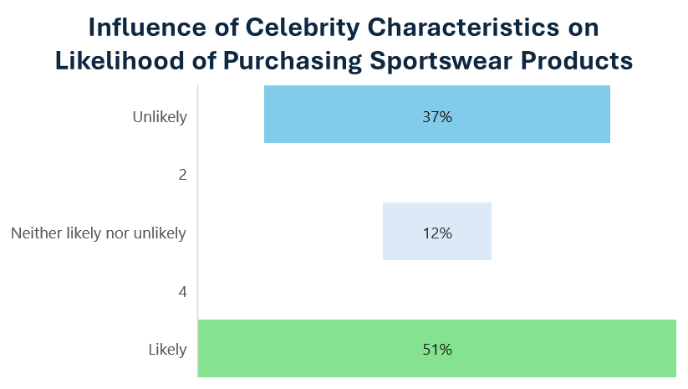

n = 159

**Analysis:**

Given that more than half (51%) of the participants indicated that they would be inclined to buy sportswear endorsed by their preferred celebrity, it is apparent that celebrity endorsements have a significant impact on consumer purchasing decisions. This high percentage shows that there is a direct link between consumer purchase intent and celebrity endorsements, underscoring the value of using celebrity appeal to boost sales and market share.

* Approximately 1/3rd of the Respondents (31%) showcased that endorsements from their favorite celebrity had an impact on the brand appeal.

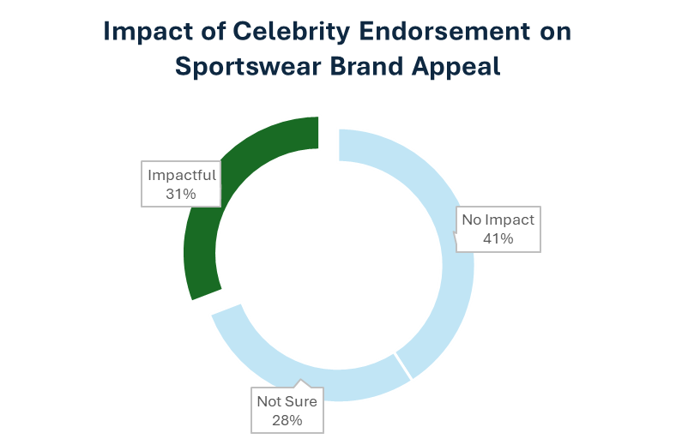

n = 159

**Analysis:**

The finding that 31% of respondents said that the attraction of the endorsed brand was positively impacted by celebrity endorsements indicates the significance of celebrity endorsements in influencing consumer perception of brands. A brand's reputation can be improved by aligning with a celebrity, which appeals to and inspires admiration in the eyes of the endorsed person's followers. Because of this association, consumers who aspire to live similar lives to their favorite celebrities may become more devoted to and prefer the brand.

**To measure the influence (popularity, trust, characteristics) of celebrity models on brand preferences in the sportswear market.**

* An overwhelming 57% of Respondents (44%) made a purchase decision solely based on the celebrity endorsement.

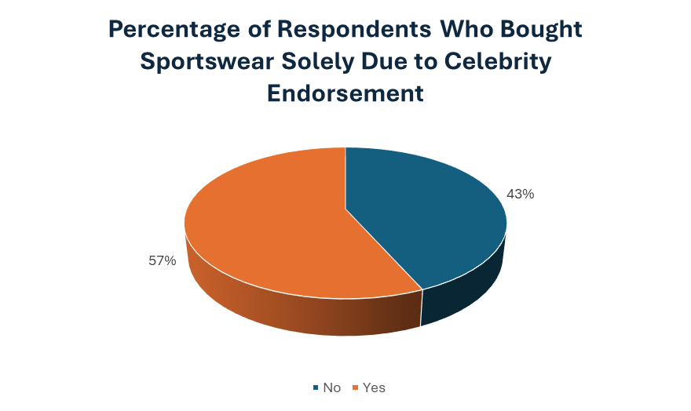

n = 159

**Analysis:**

A significant proportion of participants (57%) stated that they only base their purchasing decisions on the endorsements of celebrities. This implies that a successful marketing tactic for sportswear companies is celebrity endorsement. The data suggests that customer brand preferences in the sportswear business are significantly influenced by celebrity models.

* Entertainment and Fashion Industries related celebrities were the more convincing celebrity type for sportswear endorsements with almost 1/3rd of the respondents choosing them. However, 1/5th of the respondents didn’t find both entertainment and sports celebrities convincing enough.

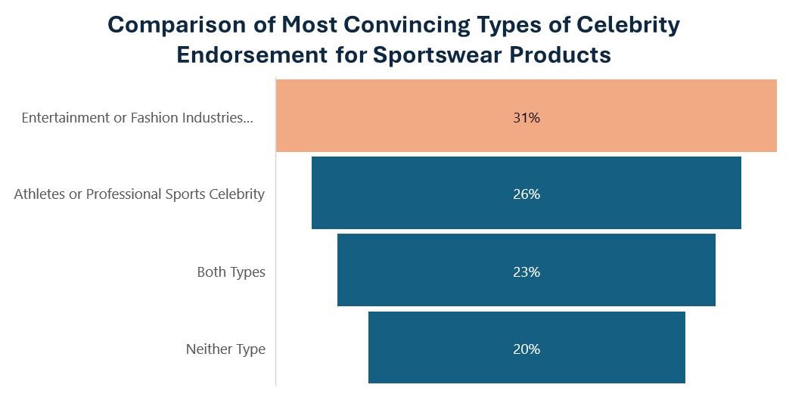

n = 159

**Analysis:**

Compared to sports superstars, the majority of respondents(1/3rd) said celebrities in the entertainment and fashion industries were more credible to advocate sportswear. This tendency may be explained by elements including aspirational attractiveness, lifestyle alignment, and the target audience's general affection for entertainment icons.

* A Celebrity's image and reputation play an impactful role on the sportswear brand perception as almost 60% of the Respondents agreed.

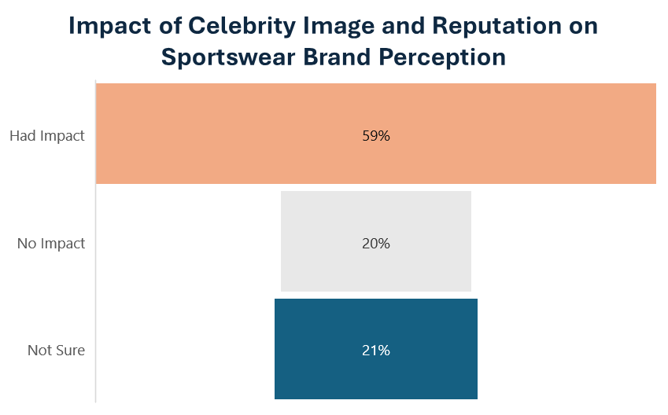

n = 159

**Analysis:**

Almost 60% of participants believed that a celebrity's image significantly influences how they view a brand. This emphasizes how crucial it is to choose brand ambassadors whose personalities fit the business's basic principles and appeal to the intended market.

**To explore how the credibility of a celebrity impacts purchase decisions for sportswear (technical know-how, social image, ethical value) in endorsing sportswear products.**

* Respondents felt that they could trust a sportswear brand or product endorsement if the celebrity endorsing the product has a history of using the products themselves.

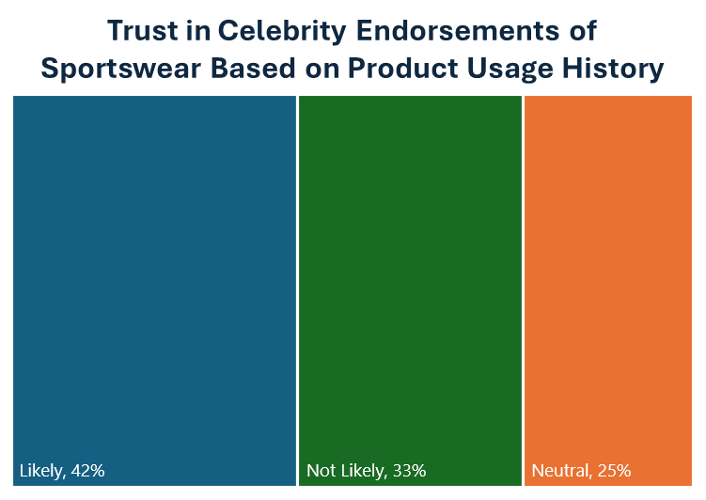

n = 159

**Analysis:**

According to research, customers consider celebrity endorsements of sportswear as more trustworthy when the celebrity has a history of utilizing the products. This implies that building trust between the customer and the recommended product requires authenticity and real experience.

* There was not a significant difference among the respondents choosing whether the celebrity endorsing the sportswear has technical knowledge about the sport.

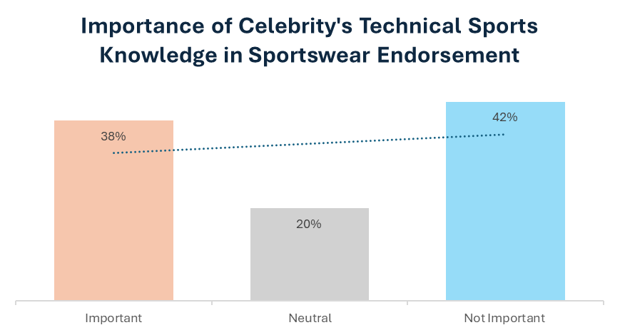

n = 159

**Analysis:**

Although authenticity is important, respondents' awareness of the celebrity's technical skills in the recommended sport did not change much. This suggests that despite technological proficiency might not be a deciding factor, it is nevertheless important for some customer groups and shouldn't be disregarded entirely.

* When it came to the effectiveness of a celebrity sharing a personal story about the sportswear brand or product while endorsing the same, respondents (39%) felt that made an endorsement much more persuasive.

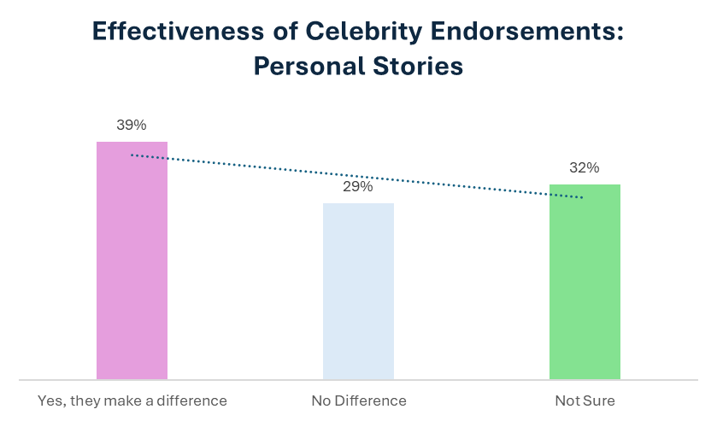

n = 159

**Analysis:**

Telling personal tales about the product being promoted greatly increases the persuasiveness of endorsements. Nearly 40% of participants believed that experiences from their own lives increased the persuasiveness of endorsements. This demonstrates the effectiveness of storytelling in marketing, particularly when it comes to emotionally engaging customers.

**Recommendations :**

**Generic Objective : To investigate the level of influence that celebrity models have on customer purchase decisions for sportswear.**

1. **Strategic Celebrity Endorsements:** Brands should strategically select celebrity models whose image and values align closely with those of the sportswear brand and its target audience. This alignment enhances credibility and resonates more effectively with consumers, increasing the likelihood of influencing purchase decisions.
2. **Diversification of Endorsers:** Brands should consider diversifying their pool of celebrity endorsers to appeal to a broader range of consumers. Different demographics may respond differently to various celebrities, so having a diverse lineup of endorsers can maximize reach and effectiveness.
3. **Engagement and Interaction:** Brands should leverage social media platforms and other channels to facilitate engagement and interaction between celebrity endorsers and consumers. Encouraging authentic interactions can strengthen the bond between consumers and the brand, driving brand loyalty and advocacy.
4. **Long-Term Relationship Building:** Instead of viewing celebrity endorsements as one-off transactions, brands should aim to cultivate long-term relationships with their celebrity endorsers. Building enduring partnerships fosters trust and credibility over time, allowing brands to capitalize on the ongoing influence of celebrities on consumer purchase decisions. This approach also enables brands to maintain consistency in their messaging and branding, contributing to sustained consumer engagement and loyalty.

**Specific Objective 1: To examine the role of demographic factors on the effectiveness of celebrity endorsements in influencing consumer purchase decisions.**

1. **Targeted Celebrity Selection:** Celebrities should be carefully chosen for endorsements by brands based on their attractiveness to particular target audiences, as consumer choices are influenced by demographic considerations. Choosing celebrities that appeal to the target market base can be made easier by carrying out in-depth market research to determine the demographics of the intended audience.
2. **Strategic Marketing choices:** To successfully express the value of their products and interest consumers' attention, brands should make use of celebrity endorsements in their marketing efforts. A larger audience can be reached and impact can be maximized by including endorsements in promotional materials across many platforms, such as print, television, and social media.
3. **Investment in Brand Image:** Building alliances with celebrities whose appearances complement the brand's identity and core values can improve consumer perception of the brand. To guarantee trustworthiness and resonance with their intended audience, brands ought to concentrate on establishing genuine relationships with celebrities.
4. **Constant Evaluation:** Using customer feedback, sales information, and brand KPIs, brands must constantly assess the success of celebrity endorsements. Brands can modify their endorsement strategy to stay competitive and relevant in the ever-evolving consumer marketplace by keeping an eye on market developments and consumer sentiment.

**Specific Objective 2: To measure the influence (popularity, trust, characteristics) of celebrity models on brand preferences in the sportswear market.**

1. **Psychographic Profiling:** Conduct in-depth psychographic profiling to understand the underlying motivations and preferences of target consumers. Select celebrity endorsers whose characteristics and values align closely with the psychographic profiles of the target audience to enhance resonance and influence.
2. **Brand-Celebrity Cooperation:** Give top priority to collaborations with celebrities whose individual brands are very compatible with the athletic brand's principles, positioning, and ethics. This consistency improves consumer impression of the brand and builds authenticity and credibility.
3. **Engagement Beyond Endorsement:** Sportswear companies need to look into ways to interact more deeply than only through standard endorsement agreements with celebrity endorsers. Engaging in cooperative endeavors like joint-creation of product lines, taking part in social impact campaigns, or providing genuine brand experiences can enhance the connection between the brand, consumers, and celebrities.
4. **Engaging Social Media Platforms:** Increase brand awareness and engagement by making use of celebrity endorsers' reach and influence on social media platforms. The brand may increase its relevance and reach among target consumers by utilizing influencer marketing techniques, distributing user-generated content, and having natural and genuine interactions with its followers.

**Specific Objective 3: To explore how the credibility of a celebrity impacts purchase decisions for sportswear (technical know-how, social image, ethical value) in endorsing sportswear products.**

1. **Focus on Authenticity:** When it comes to celebrity endorsements, sportswear companies should give priority to authenticity. Consumer trust can be increased by selecting celebrities who use and believe in the things they promote.
2. **Take Target Audience Preferences into Account:** Although technical expertise might not be an essential issue for every consumer, businesses should take various market groups' preferences into account. Celebrities with relevant technical competence endorsing specialized products or narrow markets may have greater effect.
3. **Monitor and Adjust:** Keep a close eye on customer feedback and adjust endorsement tactics as necessary. Brands must exhibit flexibility and responsiveness in response to any shifts in consumer preferences and attitudes towards celebrity endorsements.
4. **Narrative-driven Endorsements:** Incorporate personal narratives and storytelling into endorsement campaigns to create authentic connections with consumers. Encouraging celebrities to share their personal experiences with the brand can enhance credibility and emotional resonance, driving consumer trust and purchase intent.

**Appendix**

**Screener Questions**

1. Welcome to our study on sportswear purchasing behaviour. Your participation is voluntary, and all responses will be kept confidential. Do you consent to participate in this study?

· Yes

· No

2. What is your age range?

· 18-24

· 25-34

· 35-44

· 45-54

· 55+

3. Which province or territory do you currently reside in?

· Alberta

· British Columbia

· Manitoba

· New Brunswick

· Newfoundland and Labrador

· Nova Scotia

· Ontario

· Prince Edward Island

· Quebec

· Saskatchewan

· Northwest Territories

· Nunavut

· Yukon

4. What is your gender?

· Male

· Female

· Non-Binary

· Prefer not to say

· Other (please specify)

5. Do you purchase apparel products for yourself or others?

· Myself

· Others

· Both

**Main Questions/Questionnaire**

1. Would you be willing to pay a higher price for sportswear endorsed by a celebrity model you admire?

· Yes

· No

· Maybe

2. If yes, how likely are you to consider purchasing sportswear products endorsed by a celebrity you admire?

· Very Likely

· Likely

· Neutral

· Unlikely

· Very unlikely

3. Have you ever bought sportswear solely because it was endorsed by a celebrity?

· Yes

· No

4. Would you consider a sportswear brand more appealing if it is endorsed by a celebrity you admire?

· Yes

· No

· Maybe

5. How often do you purchase sportswear products?

· Daily

· Weekly

· Monthly

· Occasionally

· Rarely

6. How likely are you to research a sportswear product endorsed by a celebrity before making a purchase?

· Very Much

· Somewhat

· Neutral

· Not Much

· Not at all

7. How often do you follow celebrities or influencers who endorse sportswear brands on social media?

· Multiple times a day

· Daily

· Weekly

· Occasionally

· Rarely

8. Which type of celebrity endorsement do you find most convincing for sportswear products?

· Celebrities who are athletes or professional sportspeople

· Celebrities who are popular in entertainment or fashion industries

· Both types are equally convincing

· Neither type is convincing to me

9. How often do you engage with sponsored content featuring celebrity endorsements for sportswear products on social media?

· Always

· Often

· Sometimes

· Rarely

· Never

10. How much do you think the age of the celebrity endorser affects their influence on your purchasing decisions for sportswear?

· Strongly Agree

· Agree

· Neutral

· Disagree

· Strongly Disagree

11. Please rank the following factors in order of importance when purchasing sportswear:

· Celebrity Reputation

· Price

· Quality

· Design/Style

12. Which characteristic of a celebrity influences your brand preference the most?

|  |  |  |  |  |  |
| --- | --- | --- | --- | --- | --- |
|  | Strongly Agree | Agree | Neutral | Disagree | Strongly Disagree |
| Popularity |  |  |  |  |  |
| Trustworthiness |  |  |  |  |  |
| Likeability |  |  |  |  |  |
| Relatability |  |  |  |  |  |
| Expertise in sports |  |  |  |  |  |

13. How does the celebrity's overall image and reputation impact your perception of the sportswear brand they endorse?

· Positively

· Negatively

· No Impact

· Not Sure

14. How often do you consider purchasing a product after seeing a celebrity wearing or endorsing it?

· Always

· Often

· Sometimes

· Rarely

· Never

15. Which factors make you more likely to trust a celebrity's endorsement of sportswear products? (Select all that apply)

Their personal achievements in sports

Their reputation for honesty and integrity

Their personal style and fashion sense

Their involvement in social or environmental causes

Their popularity on social media

16. How much does the consistency of a celebrity's image with the brand influence your preference for sportswear endorsed by that celebrity? (SO2)

· Very Much

· Somewhat

· Neutral

· Not Much

· Not at all

17. How likely are you to trust a celebrity's endorsement of a sportswear brand if they have a long history of using the products themselves?

· Very Much

· Somewhat

· Neutral

· Not Much

· Not at all

18. How much does the variety of sportswear products endorsed by a celebrity impact your likelihood of purchasing from the brand?

· Very Much

· Somewhat

· Neutral

· Not Much

· Not at all

19. Do you believe that celebrity endorsements influence the quality perception of sportswear products?

· Yes, positively

· Yes, negatively

· No, not at all

· I'm unsure

20. How important is it for a celebrity endorsing sportswear to have technical knowledge about sports? (SO3)

· Very Much

· Somewhat

· Neutral

· Not Much

· Not at all

21. Would you be more likely to buy sportswear endorsed by a celebrity known for their positive social image?

· Yes

· No

· Maybe

22. Would you be more likely to purchase sportswear endorsed by a celebrity if they are known for their authenticity and genuineness?

· Yes, authenticity matters to me

· No, it doesn't influence my decision

· I’m not sure

23. Do you find celebrity endorsements more persuasive when the celebrity shares personal stories or experiences related to the endorsed sportswear brand?

· Yes, it makes the endorsement more relatable

· No, it doesn't influence my decision

· I’m not sure

24. Would you switch from your current preferred sportswear brand to one endorsed by a celebrity known for their ethical values?

· Yes

· No

· Maybe

25. How important is it for you that the celebrity endorsing sportswear products has a positive public image?

· Strongly Agree

· Agree

· Neutral

· Disagree

· Strongly Disagree

**Profiling Questions**

1. How would you describe your lifestyle?

· Active and fitness-oriented

· Fashion-conscious

· Outdoor enthusiast

· Social and trend follower

· Minimalist and practical

· Other (please specify)

2. Which of the following values are most important to you when choosing sportswear?

· Sustainability and eco-consciousness

· Performance-driven

· Fashion-forward

· Comfort and functionality

· Brand loyalty

· Other (please specify)

3. What are your primary interests or hobbies?

· Sports and athletics

· Fashion and style

· Outdoor activities

· Health and wellness

· Celebrity culture

· Other (please specify)

4. What is the highest level of education you have completed?

· High School or equivalent

· Some College/Associate's Degree

· Bachelor's Degree

· Master's Degree or higher

5. Which of the following best describes your current occupation?

· Student

· Employed full-time

· Employed part-time

· Self-employed

· Unemployed

· Retired

· Other (please specify)

6. What is your approximate annual personal income?

· Less than $25,000

· $25,000 - $49,999

· $50,000 - $74,999

· $75,000 - $99,999

· $100,000 or more

**Quotas**

**Age Quota**

○ 18 - 19-year-olds (⅖ of 15 - 19-year-olds): ⅖ * 2,012,975 = 805,190

○ 15–17-year-olds: 2,012,975 - 805,190 = 1,207,785.

○ Total Population of 15 - 64-year-olds = 23,957,760. Therefore, 18 - 64-year-olds = 23,957,760 - 1,207,785 = 22,749,975.

○ 65 and older = 7,021,430. Therefore, Total population is 18- to 64-year-olds + 65 and older (22,749,975 + 7,021,430) = **29,771,405**

○ The proportion (as a percentage) of each age group (18-34, 35-54, and 55+) to the total adult population (18 years and older)

■ Proportion (18-34): **7,947,790**/29,771,405 * 100% = 26.64%

**Sample size = 301**

■ Proportion (35-54): **9,583,270**/29,771,405* 100% = 32.15%

**Sample size = 336**

■ Proportion (55+): **12,240,340**/29,771,405* 100% = 41.07%

**Sample size = 372**

Research Papers:

De Moraes, M. B., Gountas, J., Gountas, S., & Sharma, P. (2019). Celebrity influences on consumer decision making: new insights and research directions. *MM. Journal Of Marketing Management/Journal Of Marketing Management*, *35*(13–14), 1159–1192. <https://doi.org/10.1080/0267257x.2019.1632373>

Celebrity endorsement and its impact on purchase intention of luxurious brands. (2022). In *The Business and Management Review* (pp. 285–286) [Journal-article]. <https://cberuk.com/cdn/conference_proceedings/2022-09-18-13-25-06-PM.pdf>

Ling, Z., & Whitla, P. (2013). How negative celebrity publicity influences consumer attitudes: The mediating role of moral reputation. *Journal of Business Research*, *66*(8), 1013–1020. <https://doi.org/10.1016/j.jbusres.2011.12.025>

Minh, P. Q., & Anh, B. N. T. (2020). The relationship between celebrity endorsement and brand equity: What’s happening on the social network? *Khoa HọC*, *10*(1). <https://doi.org/10.46223/hcmcoujs.econ.en.10.1.227.2020>